**Week 3 Quiz**

**LATEST SUBMISSION GRADE**

100%

1.Question 1

Because smart speakers can carry out multiple functions (such as tell a joke, play music, etc.) it is an example of Artificial General Intelligence (AGI).



True



False

**Correct**

**1 / 1 point**

2.Question 2

What are the key steps to a smart speaker function?



Speech recognition → Trigger word detection -> intent recognition -> command execution.



Trigger word detection -> intent recognition -> speech recognition -> command execution.



Trigger word detection -> speech recognition -> intent recognition -> command execution.



Trigger detection -> intent recognition -> speech recognition -> command execution.

**Correct**

**1 / 1 point**

3.Question 3

Consider this system for building a self-driving car:

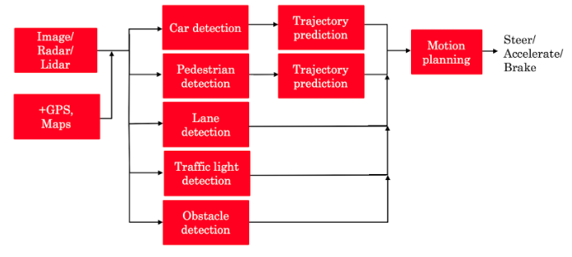

The component for pedestrian detection is usually built using:



Supervised learning



Reinforcement learning



A motion planning algorithm



GANs

**Correct**

**1 / 1 point**

4.Question 4

Suppose you are building a trigger word detection system, and want to hire someone to build a system to map from Inputs A (audio clip) to Outputs B (whether the trigger word was said), using existing AI technology. Out of the list below, which of the following hires would be most suitable for writing this software?



Machine learning engineer



Data engineer



Machine learning researcher



AI Product Manager

**Correct**

**1 / 1 point**

5.Question 5

What is the first step in the AI Transformation Playbook for helping your company become good at AI?



Develop an AI strategy



Execute pilot projects to gain momentum



Provide broad AI training



Build an in-house AI team

**Correct**

**1 / 1 point**

6.Question 6

Of the following options, which is the most important trait of your first pilot project?



Succeed and show traction within 6-10 months



Drive extremely high value for the business



Be executed by an in-house team



None of the above

**Correct**

**1 / 1 point**

7.Question 7

Say you are building a smart speaker, and want to accumulate data for your product through having many users. Which of these represents the “Virtuous circle of AI” for this product?



(A)

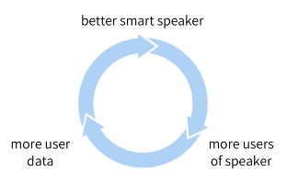



(B)

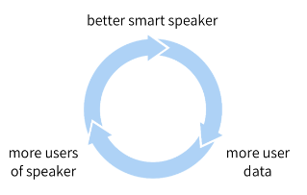



(C)

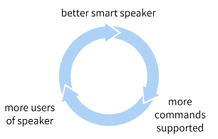



(D)

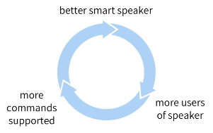

**Correct**

**1 / 1 point**

8.Question 8

Why is developing an AI strategy NOT the first step in the AI Transformation Playbook?



When transforming a company into an AI company, one does not need a strategy, therefore it can’t be the first step.



The strategy should be to use the Virtuous Circle of AI, which comes after building a product.



There is no reason. Developing an AI strategy IS the first step in the AI Transformation Playbook.



Without having some practical AI experience and knowing what it feels like to build an AI project, a company usually does not know enough to formulate a sound strategy.

**Correct**

**1 / 1 point**

9.Question 9

According to the AI Transformation Playbook, broad AI training needs to be provided not only to engineers, but also to executives/senior business leaders and to leaders of divisions working on AI projects.



True



False

**Correct**

**1 / 1 point**

10.Question 10

Which of the following are AI pitfalls to avoid? (Select all that apply)



Expecting AI to solve everything

**Correct**



Expecting AI based projects to work the first time

**Correct**



Pairing engineering talent with business talent to identify feasible and valuable projects.



Expecting traditional planning processes to apply without changes

**Correct**